**Topic : Superpixel for image processing**

**15146312 park, gang min**

**17102064 lim, chae yun**

* **The purpose of data analysis**
  + What is the problem?
    - Various analyses about images processing such as object detection and spatial division are being used in various fields. In the case of a ordinary image, there is no problem with the analysis, but When high-resolution images such as satellite images or real-time analysis such as live streaming are required, it takes an enormous amount of computations and time to perform image analysis.
* **Method**
  + How did they solve the problem using data mining?
    - Brief explanation about Superpixel

A superpixel can be defined as a group of pixels which have similar characteristics. It is generally color based segmentation. Superpixels can be very helpful for image segmentation. There are many algorithms available to segment superpixels.

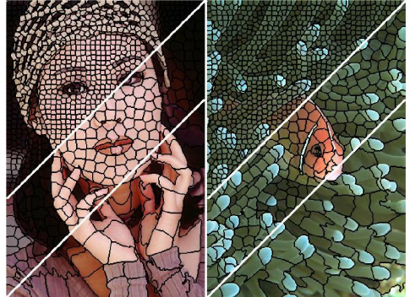

Result image of Superpixel[1]

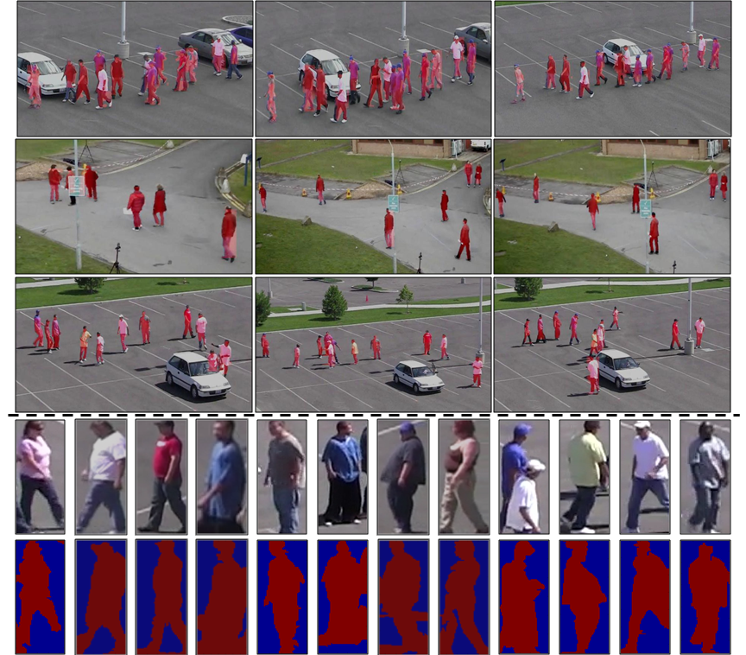

Result of object detection using Superpixel[2]

* + - Data mining in Superpixel, which techniques are used?

Various cluster analysis algorithms are used for clustering pixels to Superpixel.

K-means, Fuzzy c-means, K-medoids, SLIC(based on k-means) etc.

* + - Solution using Superpixel
      * What is important in vision-based unmanned aircraft is that real-time video processing should be possible. However, it is difficult to process images in real-time as the amount of computational power is increased for classifying entire images by applying machine learning algorithms. Therefore, super-pixels were created using a graph-based image segmentation algorithm during clustering[1].

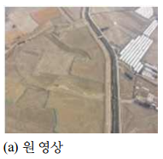

Vision-based unmanned aircraft

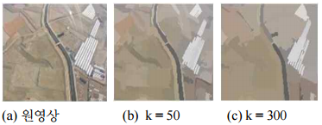

K means the number of Superpixel

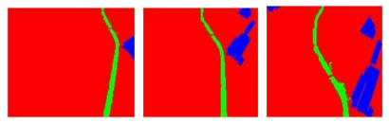

The result of object classification using Superpixel

* + What kinds of data are used?

Pixels of the image are used and mainly the distance between the color of the pixel and the pixel is used.

In the case of SLIC Superpixel algorithm, clustering is done in the five-dimensional [labxy] space, where [lab] is the pixel color vector in CIELAB color space, which is widely considered as perceptually uniform for small color distances, and [xy] is the pixel position[2].

* **Result**
  + What kinds of implication could be derived from the results of data analysis?

The number of nodes (pixels) required for image analysis can be reduced by a set of pixels with the same characteristics.

ex) 200000*100000 high resolution image -> 2000*1000 Superpixel image

* + How much benefit is obtained from the analysis?

In the example above, if you need to analyze 200000*100000 pixels for object detection, you can get results using only 2000*1000 pixels using super pixels.

* **Reference**

1. 김인규, 황승준, 나종필, 박승제, 백중환, 항공 통신 기술 : 슈퍼 픽셀기반 무인항공 영상 영역 분할 및 분류, 한국항행학회, 18, 2, 2014
2. Radhakrishna Achanta, Appu Shaji, Kevin Smith, Aurelien Lucchi, Pascal Fua, and Sabine S¨usstrunk, SLIC Superpixels

1. <https://filebox.ece.vt.edu/~jbhuang/teaching/ece5554-4554/fa16/hw4.html>
2. <https://www.crcv.ucf.edu/projects/Improving_Object_Detector/>